AI ASSISSTED CODING
4.5 ASSIGNMENT
V. Harika
2303a510i0
Batch:30
Task1: Generate Python code for two prime-checking methods and explain how the optimized version improves performance.
Code:
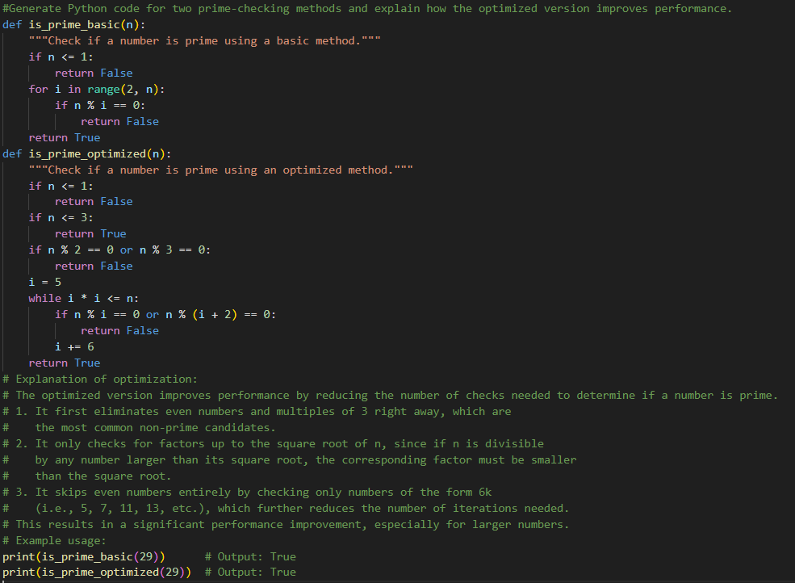
Output:
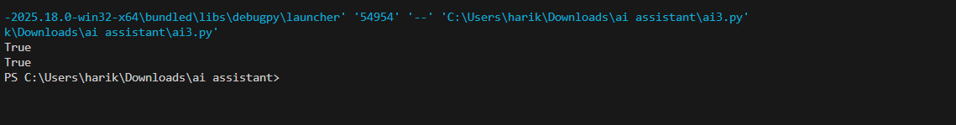
Task 2: generate a recursive function to calculate Fibonacci numbers.
Code:
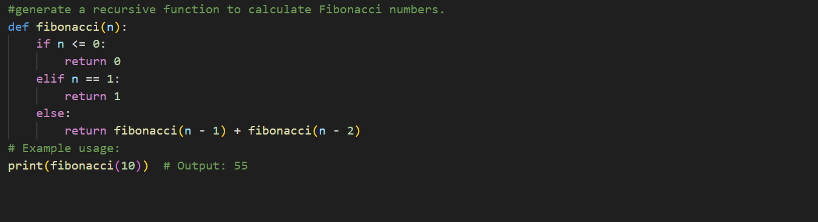
Output: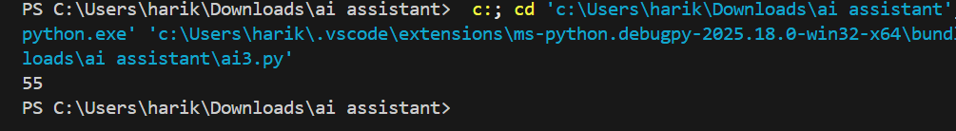
Task3: Generate code with proper error handling and clear explanations for each exception.
Code:
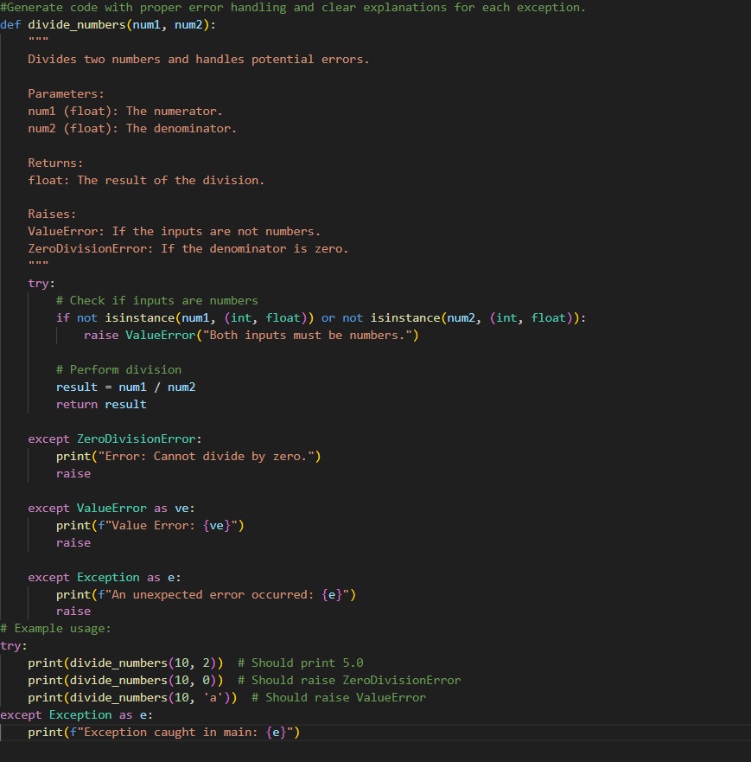
Output:
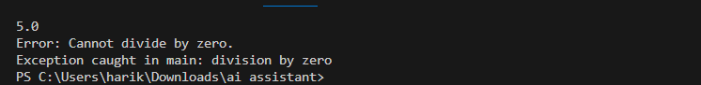
Task 4:
generate a Python-based login system.Check whether the AI uses secure password handling practices.Identification of security flaws (plain-text passwords, weak validation).Revised version using password hashing and input validation.Short note on best practices for secure authentication.
Code: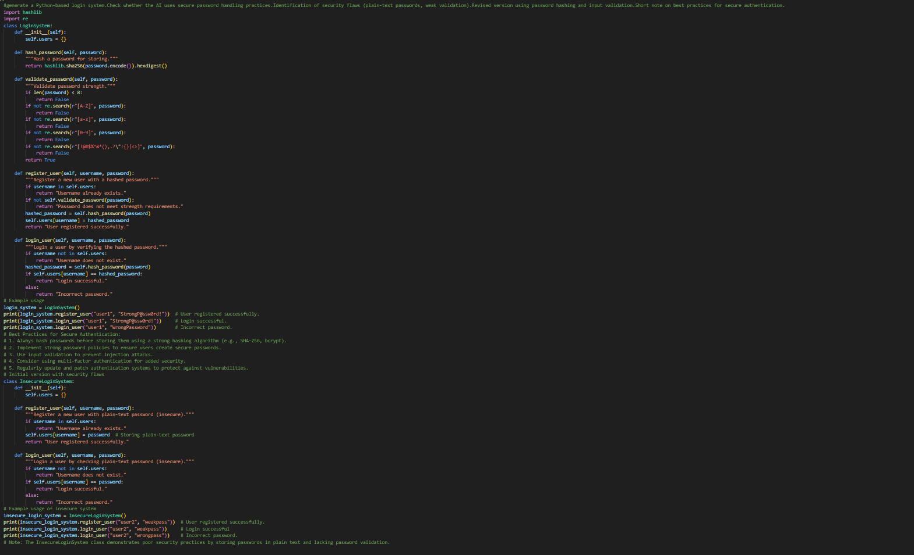
Output:
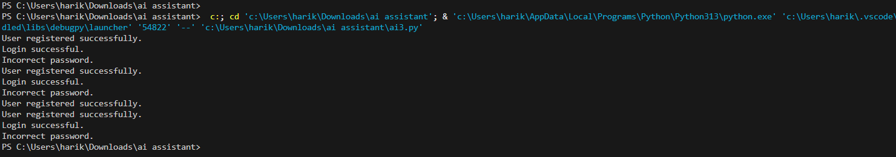
Task 5:
generate a Python script that logs useractivity (username, IP address, timestamp).Examine whether sensitive data is logged unnecessarilyor insecurely.Identified privacy risks in logging.Improved version with minimal, anonymized, or masked logging.Explanation of privacy-aware logging principles.
Code:
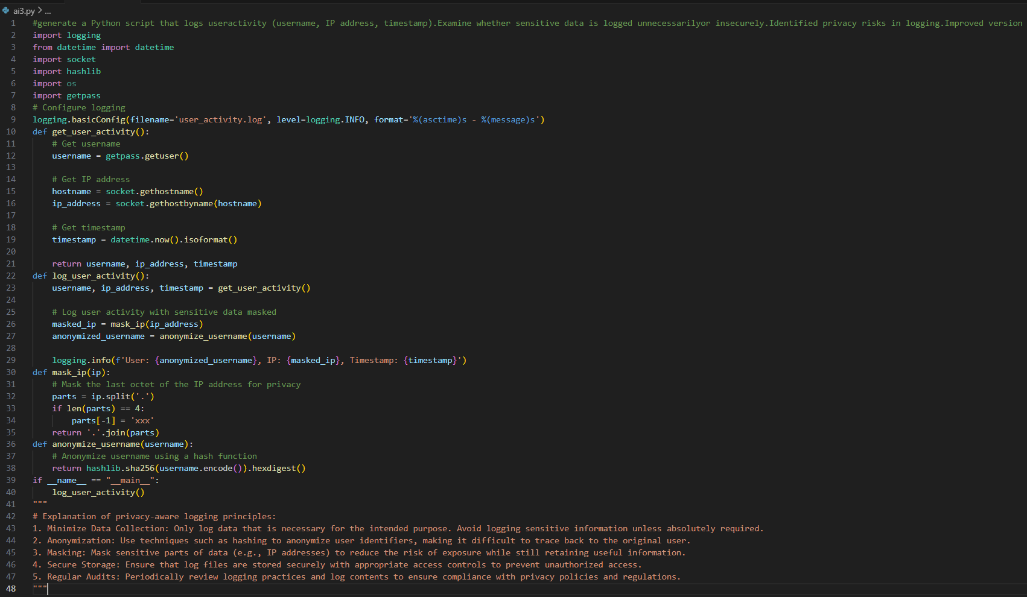
Output:

